
Company
Logotype

Cone Beam Computed Tomography- Report



Porur Dental X-rays & CBCT

Patient Name : Mrs. Maheshwari | Date of Report : 19.07.2024
Age/ Gender : 40 years/ Female | Region of Interest : CBCT Sectional Mandible
Referring doctor: Dr. Lakshmi | Indication : Assessment of 46
Clinical Notes: Nil
PATIENT INFORMATION

CBCT- Sectional Mandible provided
CBCT – IMAGE DETAILS

RADIOGRAPHIC INTERPRETATION

- In relation to 46, hyperdense restorative material involving the crown and pulp chamber is evident.
- In relation to the distal root of 46, presence of a diffuse hypodense line of discontinuity running from the furcation region to the distal pulp canal at the level of 4.62 mm from the alveolar ridge. Additionally, presence of a diffuse hypodensity involving the furcation region is evident.
- The alveolar bone in relation to 46 is present with normal trabecular pattern.

RADIOGRAPHIC IMPRESSION

- (Incompletely) Fractured distal root: 46

Kindly correlate with clinical findings


IMAGES FOR REFERENCE

RECONSTRUCTED PANORAMIC VIEW
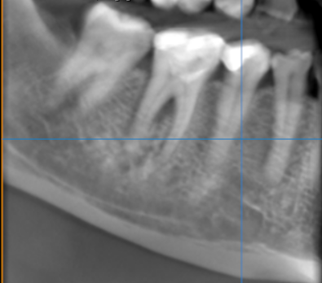

3-DIMENSIONAL VIEW
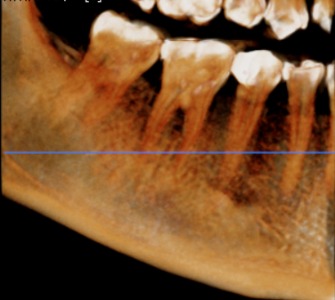

CROSS SECTIONAL VIEW
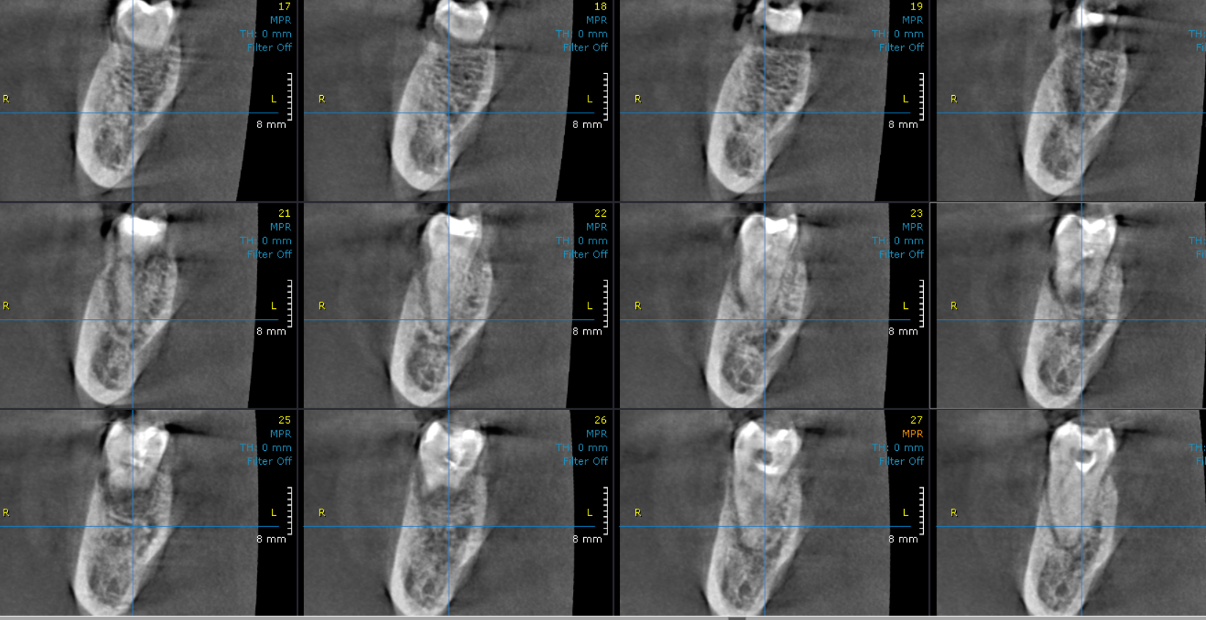

SAGITTAL VIEW
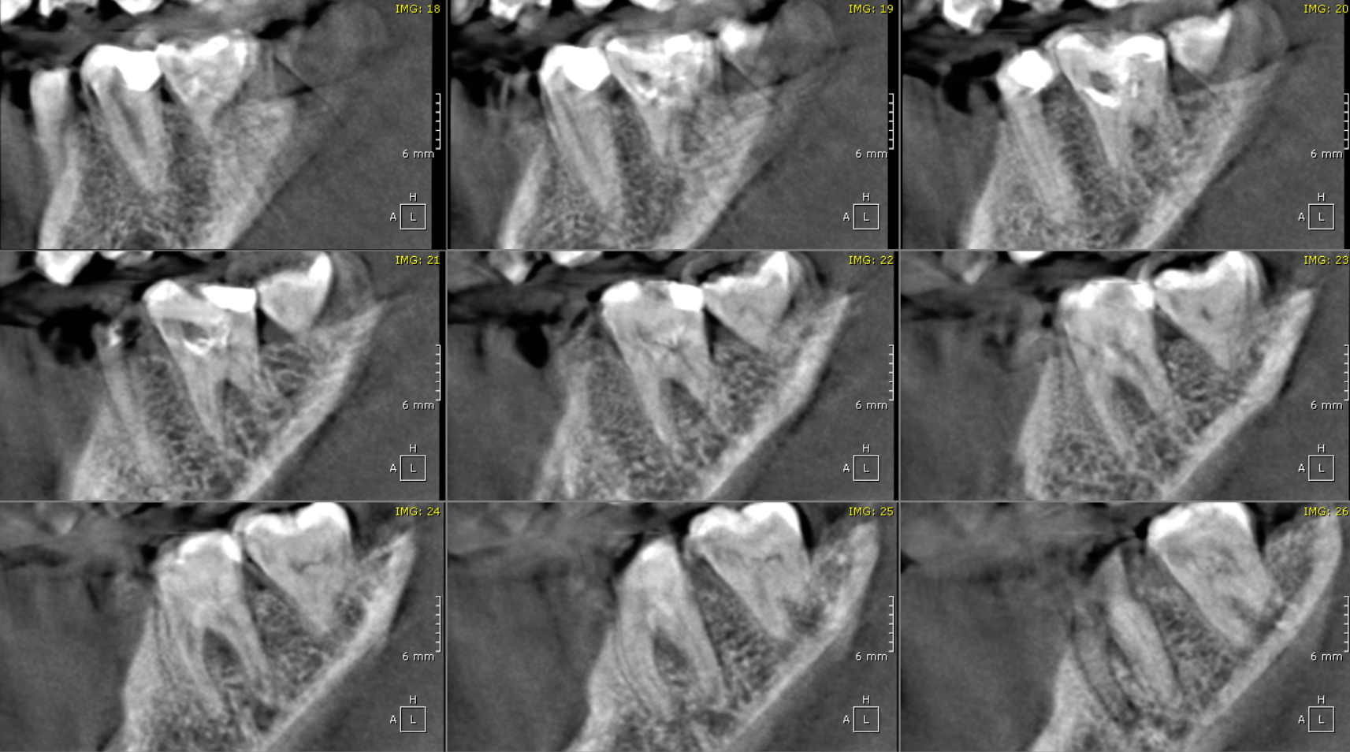

**** End of report ****

